Type of Research – Research Article

Impact of Passive Smoking among Slum Children

Mahipal Raperia
M. Phil (Management), Institute of Management Studies and Research, Maharishi Dayanand University, Rohtak, Haryana

Abstract
“Shape the Future of Life, Healthy Environments for Children. The Children of Today are the Adults of Tomorrow. They deserve inherit a safer, fairer, healthier World. There is no task more important than safe guarding their environment. Our children can grow up to realize both their human rights and their full potential for health and productivity”

According to World Health Organization, The smoke nonsmokers breathe is known as secondhand smoke and the process of breathing secondhand smoke is called involuntary smoking or passive smoking. The smoke contains thousands of toxic chemicals, including benzene, cyanide, cadmium, lead, radioactive polonium, benzo(a)pyrene, ammonia, carbon monoxide, and nicotine. Secondhand smoke (or ETS) is a very serious form of indoor air pollution. Secondhand smoke also causes and aggravates asthma and other breathing problems, particularly in children. It is also an important cause of sudden infant death syndrome (SIDS). Second-Hand Smoke (SHS) is one of the most important and most widespread exposures in the indoor environment. The link between SHS and several health outcomes, such as respiratory infections, ischaemic heart disease, lung cancer and asthma, have long been established. Nevertheless, 93% of the world population is still living in countries not covered by 100% smoke-free public health regulations, and exposure to SHS in the home is still common. Globally, more than a third of all people are regularly exposed to the harmful effects of smoke. As estimated for 2004, worldwide 40% of children, 33% of men non-smokers and 35% of women non-smokers were regularly exposed to SHS. Second hand smoke is killing over six lakh people annually, about 1% of the global burden of disease worldwide, including 1.65 lakh children before they reach their fifth birthday. This risk factor is prevalent in practically every region of the world. According to WHO assessment, 46% of adults are exposed to second hand smoke at home in the South East Asia region. WHO's Tobacco Free Initiative stated that only 7.4% of the world's population live in countries with laws to prevent smoking in public places - which safeguard non-smokers and send out strong messages about the dangers and anti-social nature of cigarettes. They recommend immediate enforcement of WHO's Framework Convention on Tobacco Control, which includes higher tobacco taxes, plain packaging and advertising bans. To protect women and children, the education campaigns on the dangers of indoor smoking are needed⁶.

Keywords: Impact, Passive Smoking, Slum Children
National Sample Survey Organization (2002)¹ adopted the definition of Slum as “a compact area with a collection of poorly built tenements, mostly of temporary nature, crowded together usually with inadequate sanitary and drinking water facilities in unhygienic conditions”. The operational definition of a Slum, originally based on recommendations of a United Nations Expert Group meeting held in 2002 and subsequently revised by UN-HABITAT in 2008, defines a Slum household as a household lacking one or more of the following:

The main reason for slum proliferation is rapid and non inclusive patterns of Urbanization catalyzed by increasing rural migration to urban areas.

Urban Population - The Census of India (2011)² reveals that the urban population of the country stood at 377 million or 31.2 per cent of the total population. The number of million plus cities has grown from 35 in 2001 to 53 in 2011, accounting for 43% of India’s urban population. Report of the High Power Expert Committee (2011)³ estimated that by 2031, India will have more than 87 metropolitan areas and the country’s urban population is likely to soar to over 600 million, adding about 225 million population to present urban population.

URBANIZATION IN SELECTED STATES
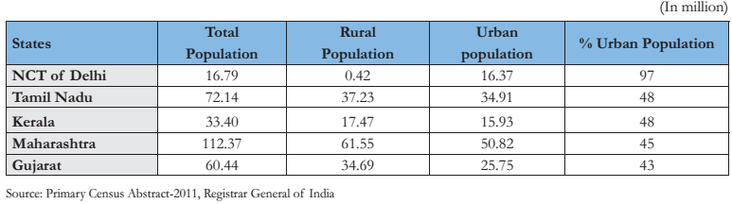
The main challenges as far as urbanization in India is concerned: The total urban housing shortage estimated at the beginning of the 12th Plan period i.e. 2012 was 18.78 million⁴
According to the 2011 Census, only 70.6% of urban households is availing the tap water as main source of drinking water. Duration of water supply in Indian cities is only between one to six hours. About 18.6% of urban households has no latrine facility within the premises, 37% of the total urban households connected by open drainage and 18% had no draining connectivity for waste water outlet. In so far as the urban transport is concerned, a Ministry of Urban Development study in 2010 based on sample of 87 cities has estimated that the air quality has also deteriorated sharply carrying with it concomitant health costs. The per capita emission levels in India’s seven largest cities have been estimated to be at least three times than WHO standards. As per the Report of the Committee on Slum Statistics/Census⁵, Slum population in the country was estimated at 75 million in 2001 and projected slum population increase from 93 million by the year 2011 to 102.7 million by 2016 respectively. A total of 65.49 million inhabitants living in 13.9 million households who have been enumerated in slums of 2613 cities/towns based on Census 2011.

SLUM AND NON-SLUM POPULATION IN INDIA - 2011
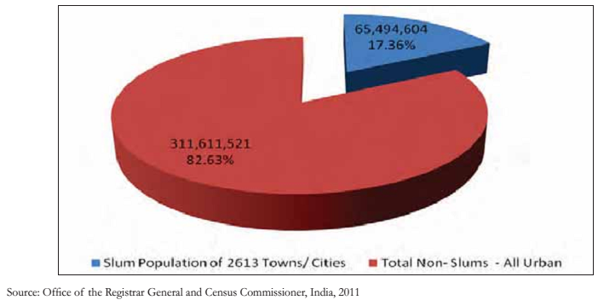
STATE/UT – wise SLUM Population as per Census 2011
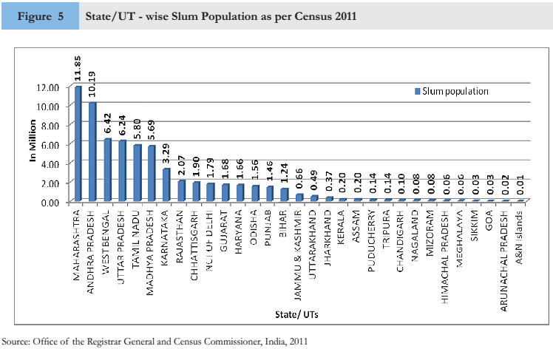
Slums in the 189 towns of Maharashtra accounts for 11.85 million population, which is 18.1 percent of the total slum population of the country. This is followed by Andhra Pradesh (10.2 million), West Bengal (6.4 million), Uttar Pradesh (6.2 million) and Tamil Nadu (5.8 million). In fact, these 5 states namely Maharashtra, Andhra Pradesh, Uttar Pradesh, West Bengal, Tamil Nadu account for about two-thirds (61.9 per cent) of the total slum population of the country.

Child Population in the Age Group 0-6 years - According to Census (2011)², about 8.08 million children are living in slums in India and they constitute 19 per cent of the total child population of the urban areas of the 31 States/Union Territories reporting slums.

Urban Child Population in Slum and Non-Slum Areas in India – 2011

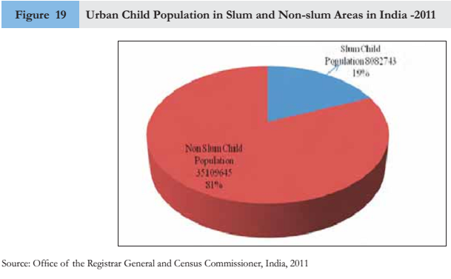
At the State/Union Territory level, around 1.4 million children (in the age group of 0-6) are residing in the slum areas of Maharashtra, followed by Andhra Pradesh (1.1 million), Uttar Pradesh (0.86 million), Madhya Pradesh (0.77 million), West Bengal (0.66 million) and Tamil Nadu (0.61 million). Maharashtra has the highest slum child population and A & N Islands (1588) have the lowest child slum population.
In 69th Round Slum (2012) Survey², at the all India level, 24 % of slums (including 32 % among notified and 18 % among non-notified slums) benefited from any welfare schemes like Jawaharlal Nehru National Urban Renewal Mission (JNNURM), Rajiv Awas Yojana (RAY), or any other schemes for improvement of slums run by the Central Government or State Government or any local body.
The United Nations has set 17 Sustainable Development Goals (SDGs) with 169 associated targets to shift the world onto a sustainable and resilient path. The goals and targets will stimulate action over the next fifteen years (i.e. till 2030) in areas of critical importance for humanity and the planet. Goal ‘1’ targets to “end poverty in all its forms everywhere” and Goal ‘11’ targets to “make cities and human settlements inclusive, safe, resilient and sustainable”. By 2030, it targets to ensure access for all to adequate, safe and affordable housing and basic services and upgrade slums.

Abu Naser Zafar Ullah et al. (2013) A total of 722 households were surveyed in urban and rural settings, using a multistage cluster random sampling approach and a semi-structured questionnaire. Qualitative methods were used to further explore the determinants of smoking-related behaviours inside homes. 55% of households had at least one regular smoker. Smoking indoors was common. In 30% of households, smoking occurred in the presence of children, exposing nearly 40% of children to SHS. Overall, found a lack of awareness about the harms associated with second-hand smoking⁷.

Vyas Sheetal, Nayak Himanshu (2012) Cross sectional study carried out in Shankar Bhuvanna Chhapara slum area of the Ahmedabad by using a pre-designed and pre-tested proforma. Total 118 houses out of 250 total houses had at least one smoker in them. Total population surveyed was 683 out of which 131 were smokers and 552 were non-smokers. The ratio of active versus passive smokers in the survey population was 1: 4.21. Firewood and kerosene were the most common fuels and majority of houses had no separate cooking area. Bidi was most commonly smoked stuff. Amongst the subjective feelings unpleasant smell was present in 74% of respondents on acute exposure to tobacco smoke and coughing was the most common immediate symptom experienced by the passive smokers. Sixty nine percent children of less than 5 years of age had history of repeated Acute Respiratory Tract Infections as per mothers¹⁵.

Öberg M, Jaakkola MS, Woodward A et al. (2011) Study presents the first estimate of the worldwide burden of disease and premature death attributable to exposure to second-hand smoke (SHS) during 2004 through a retrospective analysis of data from 192 countries. As estimated for 2004, worldwide 40% of children, 33% of men non-smokers and 35% of women non-smokers were regularly exposed to SHS. This is estimated to have caused 6,03,000 premature deaths and loss of 10.91 million Daily Adjusted Life Year’s in 2004 in non-smokers worldwide. Of the total deaths attributable to SHS, 47% are estimated to be among women, 28% among children and 26% among men. Ischaemic heart disease caused the maximum number of SHS-related deaths followed by lower respiratory infections in children <5 years, asthma in adults and lung cancer. Lower respiratory infection in children caused the maximum loss of DALYs followed by ischaemic heart disease and asthma in adults and children. The data also indicate that almost half of this total burden attributable to SHS was in Southeast Asia and Western Pacific. The estimated loss of life and health due to exposure to SHS is substantial and preventable. The authors recommend immediate enforcement of the WHO Framework Convention on Tobacco Control (FCTC) to create completely smoke-free environments. The estimates highlight the disproportionate burden of diseases attributable to SHS, with women and children being the most vulnerable group. Oberg and colleagues reported that women bear the greatest burden of deaths of the 1% worldwide mortality that is attributable to SHS and that children bear the largest burden (61%) in terms of DALYs. The numbers indicate the gravity of the problem and warrant immediate attention worldwide, and at the national level in individual countries. Children are especially vulnerable and cannot avoid exposure to SHS, if a parent or relative smokes at home. Public awareness interventions that focus on social change, through government, non-government organizations and the media are needed to ameliorate the burden of SHS exposure at home. Community mobilization campaigns will raise awareness about smoke-free laws, ensure acceptance of these laws among smokers and non-smokers alike, which will ensure 100% smoke-free environments in India¹⁰.

V.P. Chaudhari , R.K. Srivastava, M. Moitra, V.K. Desai (2008) More than 5 million children from 0-14 years old die every year from diseases linked to the environments in which they live, learn and play: their home, school and community. The World Health Day-2003 was dedicated to "Healthy Environment for Children". Over 40% of the global burden of disease attributed to environmental risk factors fall on children below 5 years of age, who account for about 10% of the world's population. A cross sectional study was undertaken to assess the influence of passive smoking over the health of under five children in Surat city. The study areas were selected by the technique of two-stage sampling. Thus, an urban slum (Morarji Vasahat) and a Middle-income group (Harinagar-3) areas were selected which were under Khatodara Urban Health Center. 788 children of Under five age group were assessed to find out the risk of passive smoking. Almost equal U 5 boys 21.6 % in urban slum area and 20.8% in MIG area were found at risk of passive smoking (2nd hand smoke). In the same way 24.8% U 5 girls in urban slum and 26.7 % in MIG area were at risk of passive smoking. One-third (37.4) U 5 children were exposed to the risk of passive smoking in urban slum area and (28.6%) in MIG area where mother were illiterate. The majority of Indians live in overcrowded homes, which make matters worse for passive smokers¹⁴.

Pembe Keskinoglu, Dilek Cimrin, Gazanfer Aksakoglua (2007) Environmental tobacco smoke is an important public health problem. The objective of the study was to evaluate the effect of passive smoking on Lower Respiratory Tract Infections (LRTIs) in children aged 2–12 years. A case-control study was conducted on matched-pair design. One-hundred and fifty children with LRTIs and 150 healthy children were included in the study. Data were collected through questionnaire and urine samples for the determination of cotinine levels and were analyzed by Mc Nemar chi-square, paired t-test and Pearson correlation tests. The prevalence of parental self-reported, indoor smoking was 71.3% in children with LRTI and 72.0% in healthy children. Employing 30 ng, the cut-off level of urinary cotinine/creatinine as commonly accepted, 87.3% of the children with LRTIs and 84.7% of healthy children were found to be passive smokers. If 60 ng of urinary cotinine/creatinine was accepted as a cut-off level, it was observed that the rates of passive smoking were 76.7% and 50.7%, respectively. Dose-dependent exposure to environmental tobacco smoke was found to be associated with the incidence of LRTI¹¹.

Gupta et al. (2001) Study of Prevalence of bronchial asthma and association with environmental tobacco smoke exposure in adolescent school children in Chandigarh covered the age group of students 9-20 years. There were 4367 (48%) boys, in whom the observed prevalence of asthma was 2.6%. Among 4723 (52%) girls, asthma was present in 90 (1.9%) students. Presence of one or more respiratory symptoms was reported by 31% students. More students with asthma had either parents or other family members smoking at home as compared to on asthmatics⁹.

Rapiti et al. (1999) Study of "Passive smoking and lung cancer in Chandigarh, India" suggests that environmental tobacco smoke exposure may be a strong risk factor for lung cancer also in India, a country with low prevalence of smoking and, therefore, low rates of lung cancer¹².

Samit J.M. (1999) Exposure of children to tobacco smoke is potentially avoidable. Maternal smoking is causally associated with reduced birth weight and increased risk for SIDS. Smoking during pregnancy has been assessed as a risk factor for a variety of behavioral and neuro-developmental problems in children: reduced general intellectual ability, skills in language and auditory tasks, academic achievement, and behavioral problems such as hyperactivity and decreased attention spans. ETS (Environmental Tobacco Smoke) exposure can be considered as a cause of lower respiratory illness (croup, bronchitis, bronchiolitis, pneumonia) in children, onset of asthma and worsening of asthma, respiratory symptoms, reduced lung growth, and middle ear disease. Active maternal smoking and ETS exposure of pregnant women and children could thus plausibly increase childhood cancer risk. During childhood, exposure to smoking by the mother and father may compromise respiratory health, increasing risk for respiratory infections and asthma and impairing lung growth¹³.

Behera et al. (1998) Study among 200 school children from North India to find out the effects of passive smoking and exposure to domestic cooking fuels on their lung functions. Forced Vital Capacity and Forced Expiratory Volume₁ were the lowest in boys whose households used biomass fuel (p<0.05). Peak Expiratory Flow Rate and Forced Expiratory Flow 25% and 50% were lowest in boys with their homes using kerosene as fuels. All these were the best for LPG fuel. However, in girls there was no significant difference in different parameters, although the values were lower in those using kerosene and biomass fuel. All parameters were lower in passive smokers irrespective of the type of fuel used although they were not statistically significant. However, Forced Expiratory Flow 50% was significantly less in passive smokers whose households used mixed fuels⁸.

Wang (1994) 8706 schoolchildren (6–18 years) followed annually: small reductions in lung functioning through adolescence associated with both current and preschool exposure to maternal smoking¹⁶.

Conclusion
“Children are our most valuable resource."
The environment affects children differently than adults. Because their bodies are still growing, children are at greater risk if they are exposed to environmental contaminants. Contaminants are anything that can cause something to become unclean, polluted, or not pure. Environmental hazards are not just outside, but can also be found inside a child's home or school. Children are not little adults—their bodies are not the same as adult bodies. Because they are small and still developing, they are more easily exposed to environmental contaminants. From birth throughout childhood, children are constantly learning and growing. One way to support positive development is to monitor the child's developmental milestones - how they play, learn, speak and act. A delay in any of these areas could be a sign of a developmental problem. Recognizing and treating a problem early can help a child reach his or her full potential. The Encyclopedia Britannica defines Slum as “Residential areas that are physically and socially deteriorated and in which satisfactory family life is impossible. Bad housing is a major index of slum conditions. By bad housing is meant dwellings that have inadequate light, air, toilet and bathing facilities; that are in bad repair, dump and improperly heated; that do not afford opportunity for family privacy; that are subject to fire hazard and that overcrowd the land, leaving no space for recreational use”.
Every fifth urban child in the country in the age group of 0-6 is a slum dweller.

Factors Contributing to Passive Smoking among Slum Children - In Census (2011) among total 137.5 lakh slum households -
- 129.4 lakh (94%) households have cooking inside house, including 89.8 lakh (65%) slum households have kitchen facility inside house, while 39.6 lakh (29%) does not have kitchen inside house.
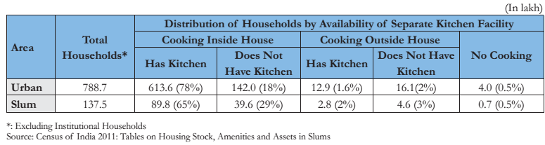
- As per data released by registrar of India in 2011² on slums of urban India on “Housing Stock, Amenities and Assets in Slums”, 90.5 % have access to electricity as main source of lighting as against 92.7 % in urban area. Kerosene is the second largest source of lighting in slum areas as 11.3 lakh (6.2%) as against 51.1 lakh (6.5%) in urban area.
- 70.5 lakh (51%) used LPG as a main source of fuel for cooking as against 65% in Urban areas, followed by 45.9 lakh (33%) slum households used firewood, corp residue, cow dung cake, coal, lignite and charcoal etc. as a source of fuel per cooking and 19.2 lakh (14%) slum households used kerosene as a main source of fuel for cooking.
- India’s first- ever census of household amenities and assets in slums has revealed that slum dwellers are also spending more on TV sets, computers and mobile phones rather than sanitation. 25.7 lakh households had radio/transistor, 95.6 lakh slum households had television, 55.2 lakh slum households had bicycle, 30.2 lakh slum households had scooter/motor/ cycle/moped, 4.9 lakh slum households had car/jeep/van, 6.3 lakh slum households had TV/computer/laptop/telephone/mobile phone and scooter/car and 14.7 lakh slum households had none of the specified assets.
- Maharashtra has the highest number of households (17.8%) among the number of dwelling rooms and majority of them (23.4%) have only one single living room.
- According to GATS Survey 2016-17, one in every three adult men and one in every six adult women uses tobacco. The number of people smoking and chewing tobacco in Maharashtra has decreased by nearly five percentage points since 2009 but Tobacco use in the 15-17 age group has nearly doubled from 2.9% to 5.5%.

Tobacco Use is a Global Problem - Tobacco use is the single preventable leading cause of death worldwide, contributing to over 5 million deaths annually. Worldwide, there are almost 1 billion male and 250 million female smokers. There is no risk-free level of exposure to secondhand smoke. Global Youth Tobacco Survey showed that almost half of the world's children are exposed to second-hand tobacco smoke (SHS). Every day an estimated 82,000 to 99,000 young people start smoking. Children are a specific target group for tobacco industry promotion.

Maternal Smoking and Prenatal Exposure

- ⇑ 60% Acute Respiratory Illnesses
- ⇑ 24 – 40% Chronic Respiratory Symptoms
- ⇑ 21% Asthma and Exacerbation of Asthma Symptoms
- ⇓ Growth in Lung Functioning
- ⇑ 50% Recurrent Otitis Media (Repeated Ear Infection)

Smoking Parents – Asthma in Children
- ⇑ 21% clinically diagnosed asthma either parent being a smoker.
- Developing asthma or wheezing is more related to maternal than paternal smoking.
- Effect was stronger for the first 5–7 years of life than for school age.

A comprehensive tobacco control legislation “The Cigarettes and other Tobacco Products (Prohibition of Advertisement and Regulation of Trade and Commerce, Production, Supply and Distribution) Act, 2003” (COTPA) is the principal comprehensive law governing tobacco control in India, passed by the parliament in April, 2003 and notified in Gazette of India on 25th 2004¹⁷. The National Tobacco Control Programme (NTCP) was launched by the Ministry of Health and Family Welfare (MoHFW), Government of India in 2007- 08, during the 11th five year plan with the objectives -
- To bring about greater awareness about the harmful effects of tobacco use and about the Tobacco Control Laws.
- To facilitate effective implementation of the Tobacco Control Laws.

The theme for World No Tobacco Day (WNTD) in 2011 is ‘The WHO Framework Convention on Tobacco Control’. On 31 May 2011, parties assessed their progress in implementing the WHO FCTC. The FCTC has come into force in 2005, but in 2008, 114 countries lacked or had limited protection from smoke-free legislation. Public awareness interventions that focus on social change, through government, non-government organizations and the media are needed to ameliorate the burden of SHS exposure at home. Community mobilization campaigns will raise awareness about smoke-free laws, ensure acceptance of these laws among smokers and non-smokers alike, which will ensure 100% smoke-free environments in India.

References
- Slums in India: A Statistical Compendium 2011, Ministry of Housing and Urban Poverty Alleviation, National Buildings Organization.
- Slums in India: A Statistical Compendium 2015, Ministry of Housing and Urban Poverty Alleviation, National Buildings Organization.
- The High Power Expert Committee (HPEC) for estimating the investment requirements for Urban Infrastructure Services was set up by the Ministry of Urban Development in May, 2008, under the Chairpersonship of Dr. Isher Judge Ahluwalia, Indian Council for Research on International Economic Relations. The Committee has submitted its report in March, 2011.
- Report of the Technical Group (TG-12) on Urban Housing Shortage (2012-17), Ministry of Housing and Urban Poverty Alleviation, National Buildings Organization.
- The Ministry of Housing and Urban Poverty Alleviation constituted a Committee under the Chairmanship of Dr. Pronab Sen to look into various aspects of Slum/Census and issues regarding the conduct of Slum Census 2011. The Committee has submitted its report on 4th July, 2008.
- Bettcher Douglas. Global Health History of Tobacco. Tobacco Free Initiative World Health Organization. 23 Mar 2011.
- Abu Naser Zafar Ullah et al. Children's exposure to second-hand smoke at home in Bangladesh: a Community Survey. BMJ Open. 2013; 3(11): e003059.
- Behera D, Sood P, Singh S. Passive smoking, domestic fuels and lung function in north Indian children. Indian J Chest Dis Allied Sci 1998 Apr - Jun; 40(2):89-98.
- Gupta D et al. Prevalence of Bronchial Asthma and association with environmental tobacco smoke exposure in adolescent school children in Chandigarh, north India. J. Asthma. 2001 Sep; 38(6): 501-7.
- Öberg M, Jaakkola MS, Woodward A, Peruga A, Prüss-Ustün A. Worldwide burden of disease from exposure to second-hand smoke: A retrospective analysis of data from 192 countries. Indian Medical Journal of India. 2011; 24 (3):164-5.
- Pembe Keskinoglu, Dilek Cimrin, and Gazanfer Aksakoglua. The Impact of Passive Smoking on the Development of Lower Respiratory Tract Infections in Children. Journal of Tropical Pediatrics. 2007; 53(5):319-24.
- Rapit E et al. Passive smoking and lung cancer in Chandigarh, India. Lung Cancer 1999 Mar; 23(3):183-9.
- Samit J.M. Synthesis: The Health Effects of Tobacco Smoke Exposure on Children. WHO/NCD/TFI/99.11
- V.P. Chaudhari et al. Risk of Passive Smoking among Under Five Children. JMGIMS. September 2008; Vol 13(II): 46 – 52.
- Vyas S et al. A Study of the Prevalence, Pattern and Health Effects of Passive Smoking in a Slum Area of Ahmedabad City. NJIRM 2012; 3(3): 85-89.
- Wang X et al. A longitudinal study of the effects of parental smoking on pulmonary function in children 6-18 years. American Journal of Respiratory and Critical Care Medicine. 1994; 149(6):1420-5.
- Dahiya Heaven. National Health Programmes. 1st Ed. Kumar Publishing House. 2018; 19-24.

